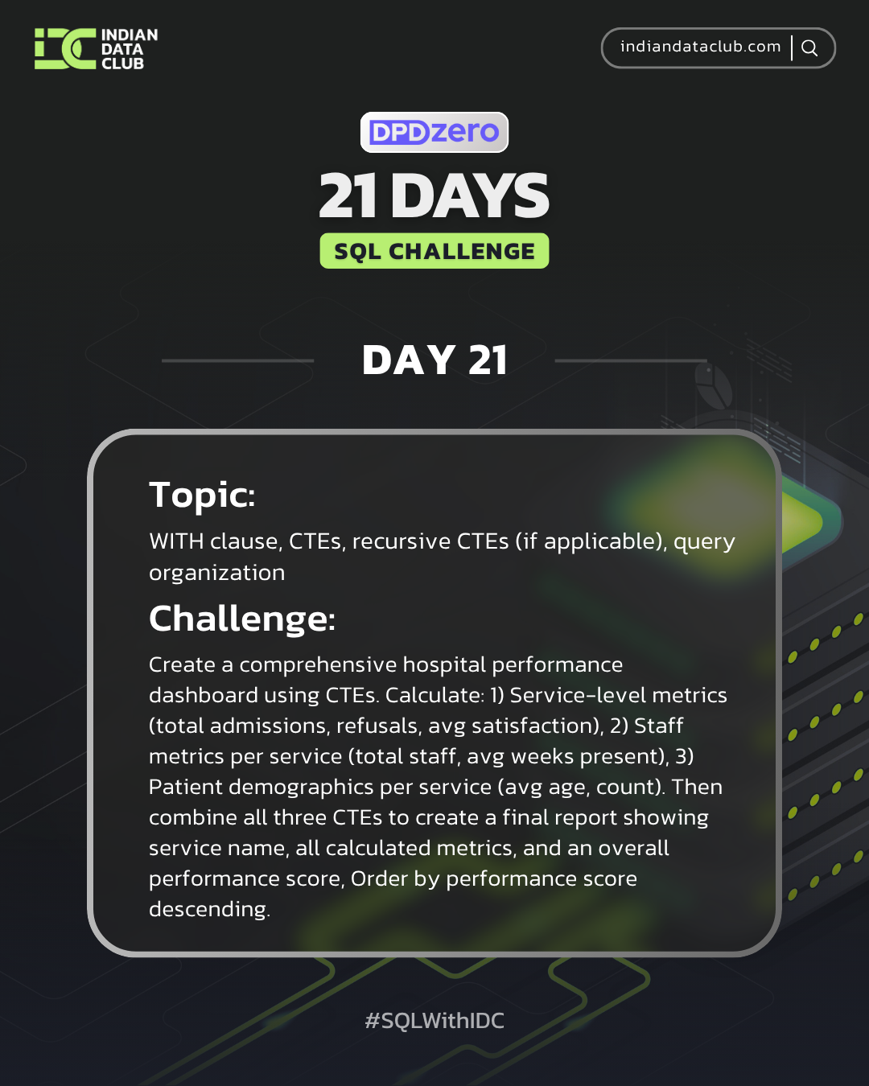
Day-21 SQL Challenge
Day-21 Challenge:
Create a comprehensive hospital performance dashboard using CTEs. Calculate: 1) Service-level metrics (total admissions, refusals, avg satisfaction), 2) Staff metrics per service (total staff, avg weeks present), 3) Patient demographics per service (avg age, count). Then combine all three CTEs to create a final report showing service name, all calculated metrics, and an overall performance score (weighted average of admission rate and satisfaction). Order by performance score descending.
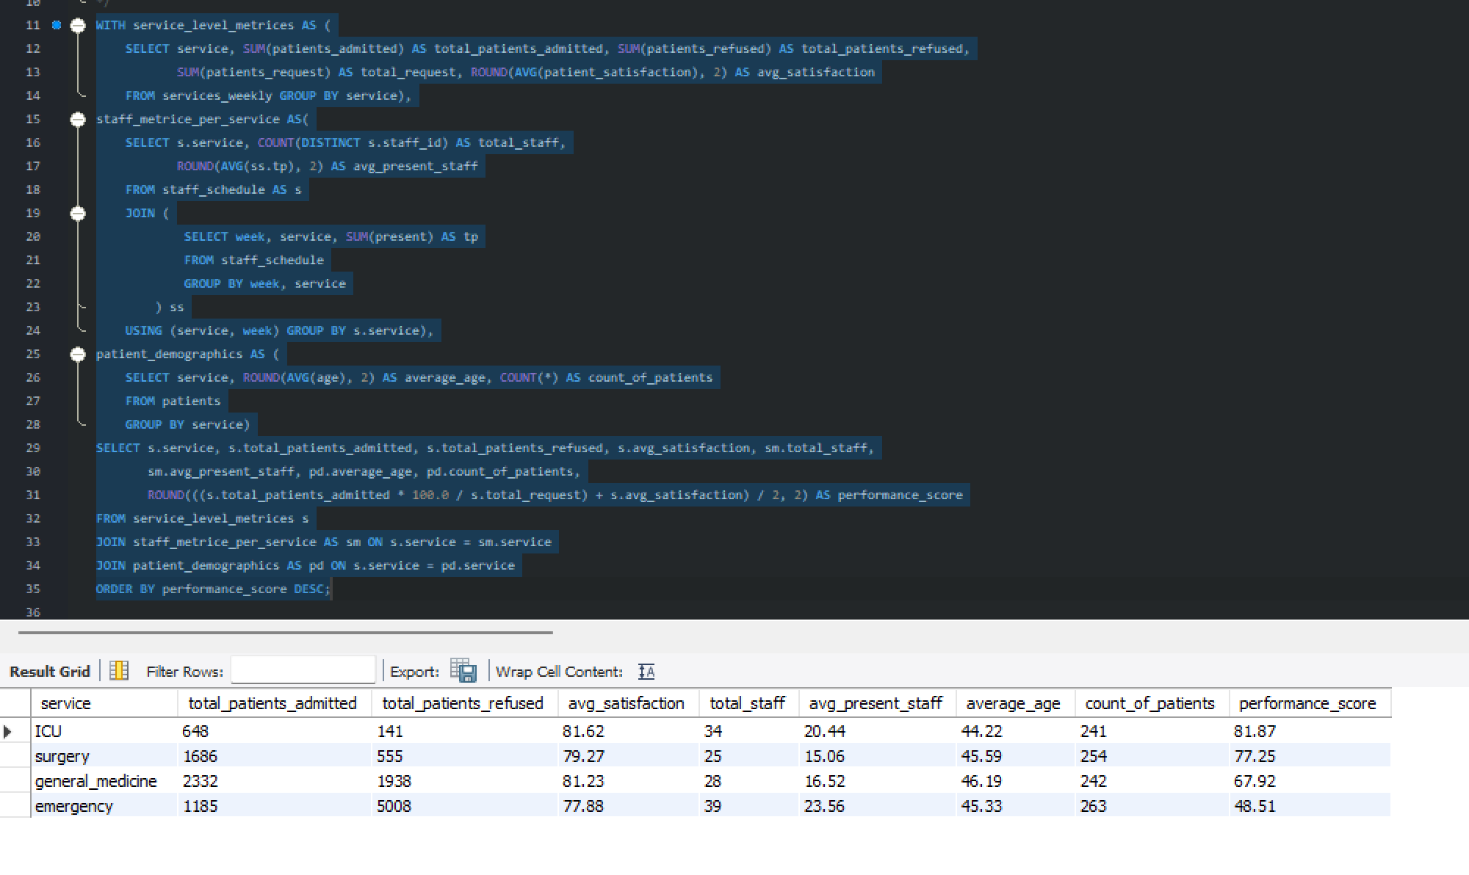

Practice Questions:
1. Create a CTE to calculate service statistics, then query from it.
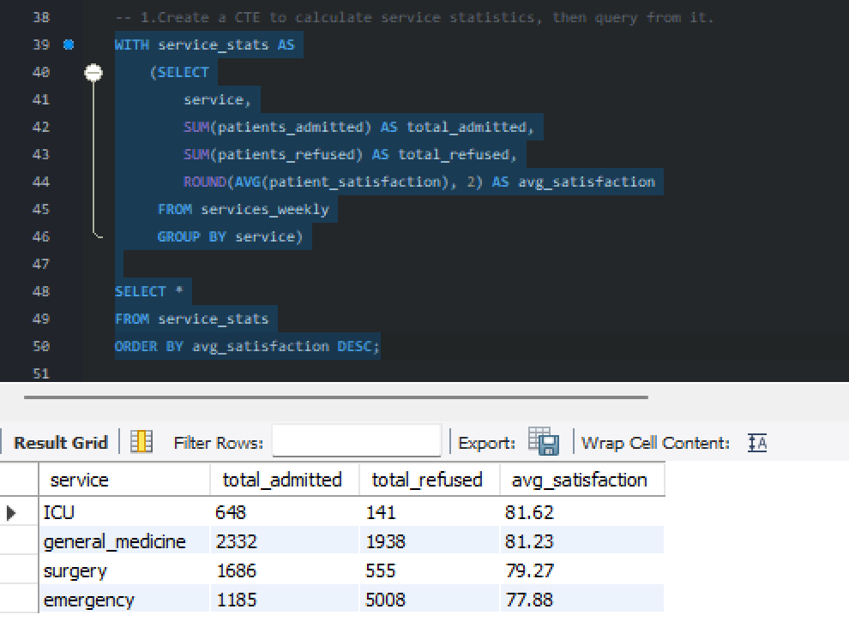

2. Use multiple CTEs to break down a complex query into logical steps.
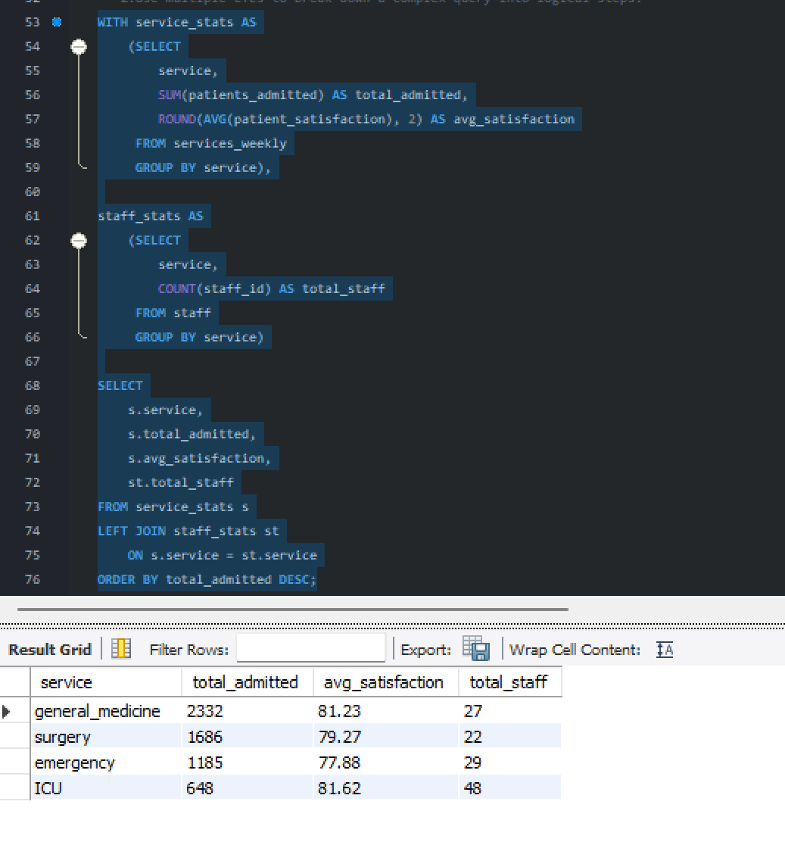
3. Build a CTE for staff utilization and join it with patient data.
